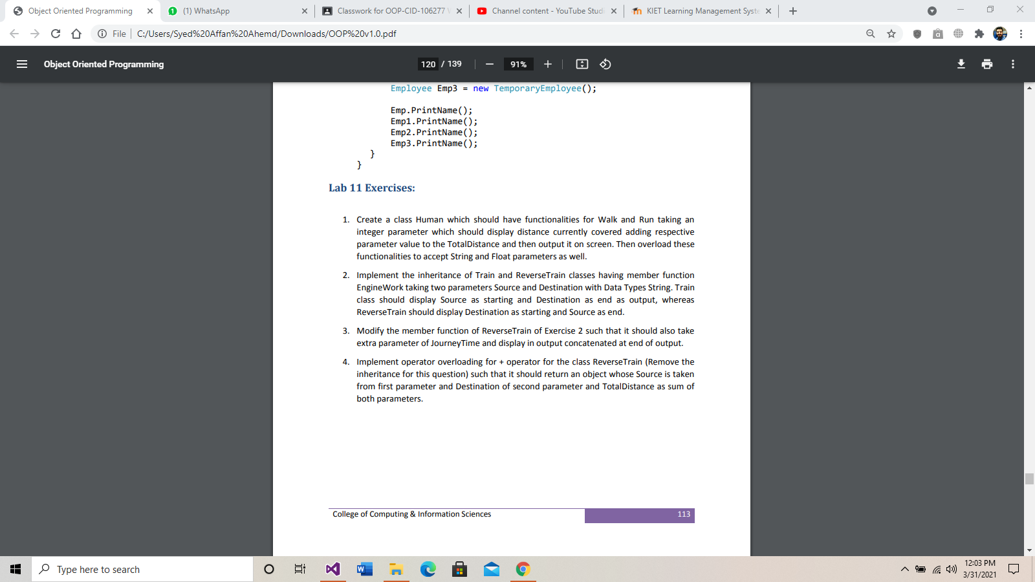

**ANSWER 1:**

**CODE:**

using System;

namespace lab12

{

class Human

{

double TotalDistance;

double total;

public Human()

{

TotalDistance = 0;

total = 0;

}

public void walk(int distance)

{

TotalDistance += distance;

Console.WriteLine(TotalDistance);

}

public void walk(string distance)

{

TotalDistance += Convert.ToDouble(distance);

Console.WriteLine(TotalDistance);

}

public void walk(float distance)

{

TotalDistance += Convert.ToDouble(distance);

Console.WriteLine(TotalDistance);

}

public void run(int distance)

{

total += distance;

Console.WriteLine(total);

}

public void run(string distance)

{

total += Convert.ToDouble(distance);

Console.WriteLine(total);

}

public void run(float distance)

{

total += Convert.ToDouble(distance);

Console.WriteLine(total);

}

}

class Program

{

static void Main(string[] args)

{

Human human = new Human();

Console.WriteLine("=========walking================");

human.walk("12");

human.walk(12);

human.walk(12.3123f);

Console.WriteLine("===========runing============");

human.run("23");

human.run(23);

human.run(23.234f);

}

}

}

**OUTPUT:**

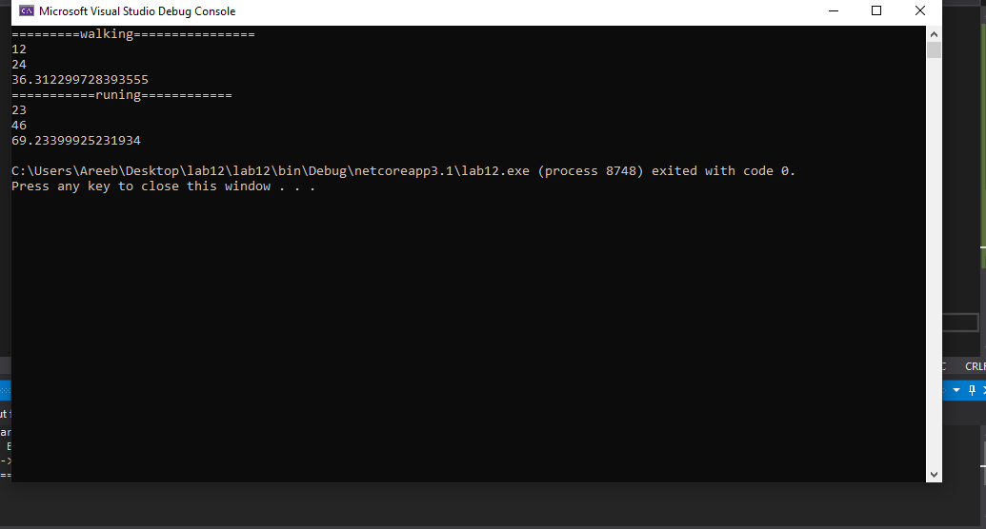

**ANSWER 2:**

**CODE:**

using System;

namespace lab12

{

class Train

{

public virtual void EngineWork(string Source, string Destination)

{

Console.WriteLine("=====================Train class===============");

Console.WriteLine("Source "+Source);

Console.WriteLine("Destination "+Destination);

Console.WriteLine("===============================================");

}

}

class ReverseTrain:Train

{

public override void EngineWork(string Source, string Destination)

{

Console.WriteLine("=====================ReverseTrain class===============");

Console.WriteLine("Source "+Source);

Console.WriteLine("Destination "+Destination);

Console.WriteLine("======================================================");

}

}

class Program

{

static void Main(string[] args)

{

Train t1 = new Train();

t1.EngineWork("Starting","Ending");

Train t2 = new ReverseTrain();

t2.EngineWork("Ending", "Starting");

}

}

}

**OUTPUT:**

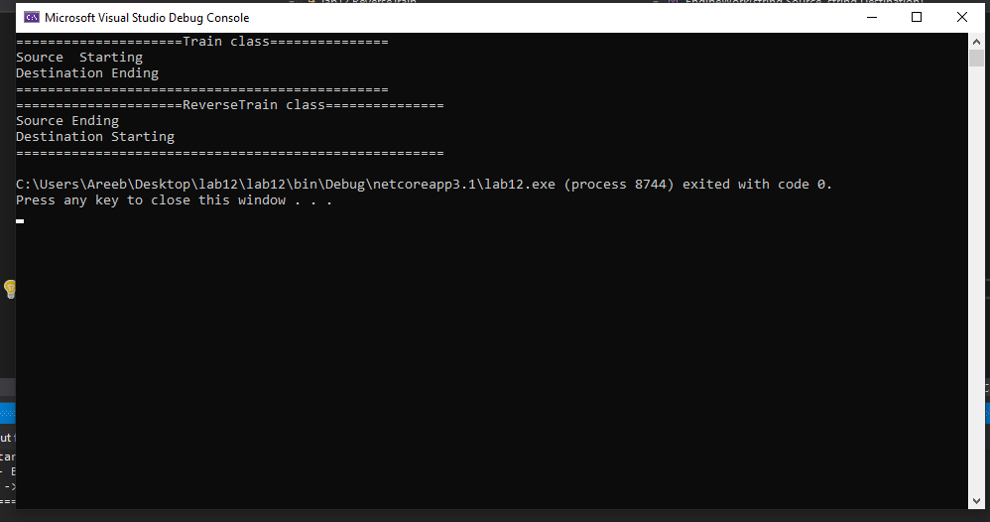

**ANSWER 3:**

**Code:**

using System;

namespace lab12

{

class Train

{

public void EngineWork(string Source, string Destination)

{

Console.WriteLine("=====================Train class===============");

Console.WriteLine("Source " + Source);

Console.WriteLine("Destination " + Destination);

Console.WriteLine("===============================================");

}

}

class ReverseTrain : Train

{

public void EngineWork(string Source, string Destination, string JourneyTime)

{

Console.WriteLine("=====================ReverseTrain class===============");

Console.WriteLine("Source " + Source);

Console.WriteLine("Destination " + Destination);

Console.WriteLine("Concatenated " + JourneyTime);

Console.WriteLine("======================================================");

}

}

class Program

{

static void Main(string[] args)

{

Train t1 = new Train();

t1.EngineWork("Starting", "Ending");

ReverseTrain r1 = new ReverseTrain();

r1.EngineWork("Ending", "Starting", "Time");

}

}

}**Output:**

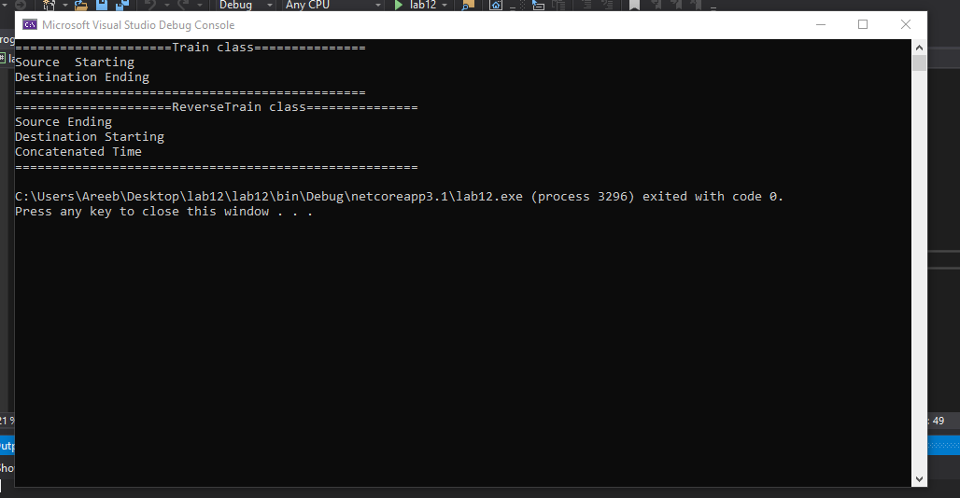

**ANSWER 4:**

**CODE:**

using System;

namespace lab12

{

class ReverseTrain

{

public int S, D;

public static ReverseTrain operator +(ReverseTrain source, ReverseTrain destination)

{

ReverseTrain r1 = new ReverseTrain();

r1.S = source.S + destination.S;

r1.D = source.D + destination.D;

return r1;

}

public void print()

{

Console.WriteLine("Total source= " + S);

Console.WriteLine("Total destination= " + D);

int totalSum = S + D;

Console.WriteLine("Total Sum of Source and destination= " + totalSum);

}

}

class Program

{

static void Main(string[] args)

{

ReverseTrain source = new ReverseTrain();

source.S = 40;

source.D = 40;

ReverseTrain destination = new ReverseTrain();

destination.S = 30;

destination.D = 30;

ReverseTrain totalSum = null;

totalSum = source + destination;

totalSum.print();

}

}

}

**OUTPUT:**

